Aras Corporation
© 2005 Aras Corporation. All rights reserved

Notice of Rights
All rights reserved. Aras Corporation (Aras) owns this document. No part of this document may be reproduced or transmitted in any form by any means, electronic, mechanical, photocopying, recording, or otherwise, without the prior written permission of Innovator and other Aras product names and logos are trademarks of Aras Corporation.

Notice of Liability
The information contained in this document is distributed on an “As Is” basis, without warranty. While every precaution has been taken in the preparation of this document, Aras shall have no liability to any person or entity with respect to any loss or damage caused or alleged to be caused directly or indirectly by the information contained in this document or by the software or hardware products described in it.

Aras Corporation
Heritage Place
439 South Union Street
Lawrence, MA 01843

Phone: 978-794-7643
Fax: 978-794-9826

E-mail: info@aras.com
Website: http://www.aras.com

Table of Contents
Quality Planning 1
APQP Library 2
Identities and Permissions 5
Create a new User 6
Create a new Identity Group 7
Configure Lists 7
Templates 8
Create a Template 8
Quality Planning Documents 10
Design FMEA 10
Create a DFMEA 11
Creating the DFMEA Editor 16
View the InBasket 17
Task Completion Worksheet 17
Plant Locations 18
Create a Plant Location 18
Tools 19
Create a Tool 19
Process Planner 20
Process Flow Diagram 21
Create a Process Flow Diagram 21
Control Plan 23
Create a Control Plan 23
Process FMEA 25
Create a Process FMEA 25
Deleting 26
Parts 28
Create a new Part 28
Relationship Tabs 30
Characteristics 30
Create a Characteristic 30
BOM 33
Create a Part Family 33
Clone Documents 34
Exercise 1 35
Exercise 2 36
Exercise 3 38
Exercise 4 40
Exercise 5 42

Quality Planning
Innovator Quality Planning Solution provides users with an easy-to-use solution for creating complex documents. The documents have relationships to one another and share some common elements. Quality Planning contains several living documents:
- Design Failure Mode and Effects Analysis (DFMEA)
- Process Failure Mode and Effects Analysis (PFMEA)
- Process Flow Diagram (PFD)
- Control Plan (CP)
Usually a team of engineers that have expertise in design, analysis/testing, manufacturing, assembly, service, recycling, quality and reliability are responsible for the preparation of the FMEA. The FMEA can be initiated by an OEM, a supplier or a subcontractor. Each FMEA must be kept up to the latest revision and the latest relevant actions.

To launch Quality Planning:
Type the URL to the server, the login dialog box appears:
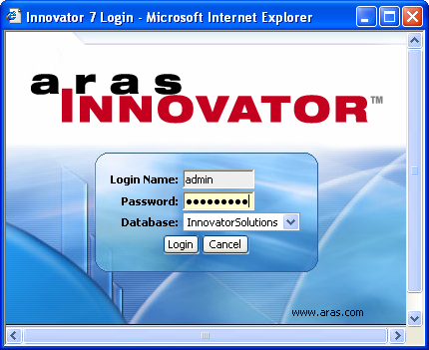
Enter your Login Name:
Enter your Password:
Select the Database:
The left side of Innovator screen displays the Categories/Folders that contain all Innovator Items.
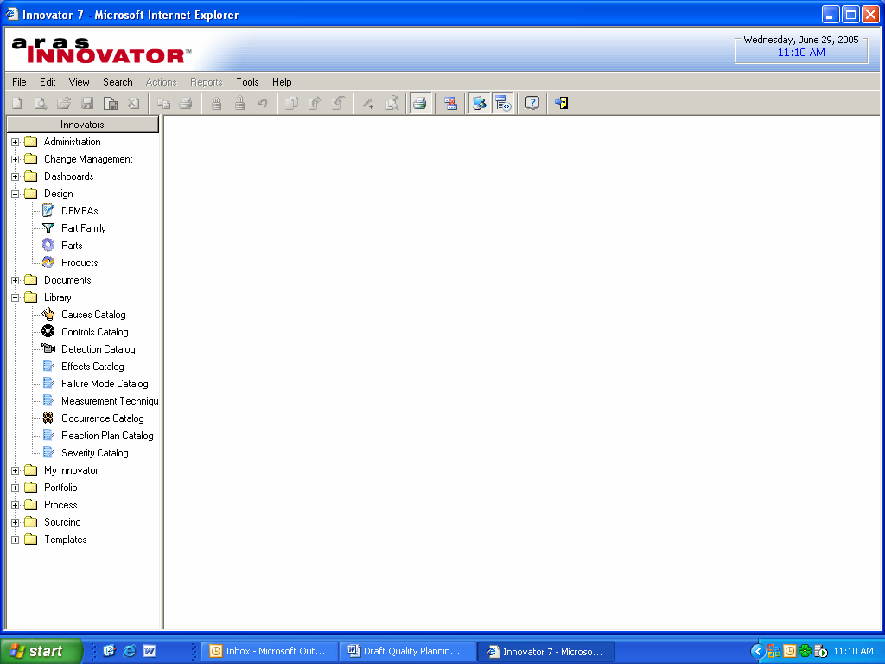
The folders that apply to Quality Planning are:
Category/Folder | Items
Administration | Core Innovator
APQP Library | Catalogs
Design | DFMEA, Parts, Part Family
Documents | Documents
Process | Plant Locations, Tools, Process Planner

APQP Library
The library contains various catalogs that are used in the FMEA form, in order to simplify and streamline the document creation process. The APQP Library is a list of Catalogs that contain standard responses the users can use when editing forms. Using catalogs assures consistency throughout the various documents, and allows easier tracking with scorecards and metrics. For example, when entering a failure mode of say "leakage" there are many variations of the actual text: it leaks; leaks are noted; leakage; etc. However, when the text is standardized, it is easier to simply select from a list, and it is always consistent. This consistency is fundamental in order to analyze the information further. For example, the company may wish to conduct research into how many parts actually fail in the field in the same modes that they are tested. If the information in the FMEAs is standardized, it can be quickly and effectively pulled out into metrics, reports, queries, and any other analytical tools.
Each Catalog is an ItemType and can be customized according to the specifications of the company’s requirements. The following is a list of Catalogs that are installed in the APQP Library.
Detection, Occurrence and Severity are the only Catalogs with predefined Items. Each catalog has 10 predefined rankings ranging from 1 – 10. Each ranking is listed twice, one for the Design FMEA and the second for the Process FMEA. All other catalogs are custom created.
Catalog | Description
Causes Catalog | Used to list the typical failure causes that may occur. Each company will have a list of causes based on their specific product and when the cause should be used
Control Catalog | Used to list the activities that must be completed based on the cause. There are two types of controls, Prevention and Detection
Detection Catalog | The rank associated with the best detection control listed in the design control. This catalog comes with 10 predefined rankings one for each FMEA, design & process
Effects Catalog | Describes what effects might occur for the potential failure mode
Failure Mode Catalog | Lists the manner in which a process might potentially fail
Measurement Technique Catalog | The measurement method to be used, i.e., Visual Inspection etc.
Occurrence Catalog | A consistent occurrence ranking system to be used to ensure continuity. This catalog comes with 10 predefined rankings one for each FMEA, design & process
Reaction Plan Catalog | A list of reaction plans, i.e., Rework in Station or Segregate NCF etc.
Severity Catalog | Is the rank associated with the most serious effect for a given failure mode. This catalog comes with 10 predefined rankings one or each FMEA, design & process

Add an Item to a catalog
- In the TOC tree click the “+” to the left of APQP Library to expand the folder.
- Select Measurement Technique, right click and choose New or click the New icon on the toolbar.
- Type in the Cause Insufficient wax thickness specified.
- Type in the Usage When Pressure exceeds xxx.
- Click on the Save, Unlock & Close icon on the toolbar.
As stated above each catalog is an ItemType and can be created via the Administration section of Innovator.

Create a new Catalog
Although catalogs are lists of information, each catalog is a separate ItemType. Unlike a list which can only be selected from, because the catalog is an ItemType, instances can be added or edited via the specified Catalog Item in the TOC tree.
- In the TOC tree click the “+” to the left of Administration to expand the folder.
- Select ItemTypes, right click and choose New or click the New icon on the toolbar.
- Name the ItemType APQP Follow Up Actions.
- Name the Label Follow Up Actions.
- Click on the Properties Tab and click on the New Relationship icon to the right of Pick Related.
- Name the Property Action.
- Name the Label Action.
- Set the Data Type to String, Length 40, and Width 140.
- Repeat steps 5-8 to create a second Property naming it Usage.
Permissions and TOC access must be set in the ItemType before closing out.

Grant Permissions
- Click the Permissions tab.
- Click on the New Relationship icon to the right of Pick Related.
- Click on the Run Search icon on the toolbar.
- Select QP Library from the list and click the green checkmarkicon on the toolbar.
- Enter a checkmark for Default.
Multiple permissions can be entered for an ItemType, however only one can be set as the default at any one time. Users with Can Change Access can change the permission default for an Item instance.
- Click on the TOC Access tab and click on the New Relationship icon to the right of Pick Related.
- Click on he Search icon on the toolbar.
- Select QP Admin from the list and click the green checkmarkicon on the toolbar.
- Click into the grid below Category and select APQP Library from the list.
Note: The Categories listed here can be added or removed via the List Item/Categories in the TOC tree.
- Click on the Can Add tab and click on the New Relationship icon to the right of Pick Related.
- Click on he Search icon on the toolbar.
- Select QP Admin from the list and click the green checkmarkicon on the toolbar.
- Click the Save, Unlock and Close icon on the toolbar.

Identities and Permissions
Permissions in Innovator are assigned to alias or group Identities not User logins. Every user created in Innovator has an alias identity assigned to them. This identity by default is the first and last name of the user and can be changed if necessary. It is a good idea to create an organizational chart of the Identity Groups required, i.e., Engineering, Quality Control etc., and the users assigned to those groups before creating permissions in Innovator. Alias and group identities can be members of multiple groups.
Quality Planning comes with some predefined Identities
- QP Admin The person assigned as the Quality Planning Administrator
- Quality Planning Design Team responsible for creating FMEAs
- All Employees All company employees
Note: When assigning users to the All Employees identity, use group identities. All users contained in the group will automatically inherit the permissions of that group identity.
The table below describes the permissions assigned to the Part ItemType:
Identity | Get | Update | Delete | Can Change Access
Aras PLM
Manager
Owner
Creator
All Employees
The table below describes the permissions assigned for Part Family:
Identity | Get | Update | Delete | Can Change Access
All Employees
Creator
The table below describes the permissions assigned to the Catalogs:
Identity | Get | Update | Delete | Can Change Access
QP Admin
Quality Planning
All Employees
When working with permissions and identities, whenever possible, work with identity groups instead of alias identities. This will make managing permissions easier. If an employee leaves the company or moves to a different department their replacement alias identity is added to the department level and will have access rights to all permissions set for that department.
Note: In order to be able to view and attach parts to a FMEA make sure the QP Admin and Quality Planning identities are added to the All Employees identity.

Create a new User
- In the TOC tree click the “+” to the left of Administration to expand the folder.
- Select Users, right click and choose New or click the New icon on the toolbar.
- Type Engineer for First Name and One for Last Name.
- For the Login type Eng, Password 1.
- Enter a checkmark for Login Enabled.
Note: If Login Enabled is uncheck for a user, that user will not be able to login into Innovator.
- Click on the Save, Unlock & Close icon on the toolbar.

Create a new Identity Group
- In the TOC tree click the “+” to the left of Administration to expand the folder.
- Select Identities, right click and choose New or click on the New icon on the toolbar.
- Name the Identity Engineering Group.
- Description Group responsible for Design.
- Click the New Relationship icon to the right of Pick Related.
- Click on he Search icon on the toolbar.
- Select Engineer One, Two and Three from the list and click the green checkmarkicon on the toolbar.
- Click the Save, Unlock and Close icon on the toolbar.
- Repeat the above steps to add another group, Assembly and Operations, assigning Engineer One.

Add an Identity to a Group
- In the TOC tree click the “+” to the left of Administration to expand the folder.
- Select Identities.
- In the search criteria line type in Q* or Q% and click on the Run Search icon on the toolbar.
- Select Quality Planning for the list, right click and choose Edit.
- Click the New Relationship icon to the right of Pick Related.
- Click on he Search icon on the toolbar.
- Select Engineer One from the list and click the green checkmarkicon on the toolbar.
- Click the Save, Unlock and Close icon on the toolbar.

Configure Lists
Catalogs are a way of configuring lists for the user to pick from as in the APQP Library. However, Catalogs are ItemTypes and are listed in the TOC tree where instances can be created. Another way of listing information is via a List Item. Unlike catalogs Lists are bound items. The only value that can be entered into the field must be entered from the value in the list. Whereas Catalogs are unbound, a user can type in a value if it doesn’t exist in the list.
One of the lists that come with Quality Planning and is a predefined list of FEMA characteristic classes. These characteristics classes will differ depending on the OEM.
Value | Description
CC | Critical Class
FF | Fit or Functional
SC
S | Safety
MC | Main Characteristic

Edit a List
- In the TOC tree click the “+” to the left of Administration to expand the folder.
- Select Lists.
- In the search criteria line type in F* or F% and click on the Run Search icon on the toolbar.
- Select FMEA Characteristic Class for the list, right click and choose Edit.
- Click the New Relationship icon to the right of No Related.
- For the Label and the Value type PC.
Leave the Sort column blank, Innovator will take the highest number listed and increment it by 128. To change the order of the list, just reassign the numbers in the Sort column accordingly.
- Click the Save, Unlock and Close icon on the toolbar.

Templates
It is possible that many parts will share the same quality planning documents. An easy way to do this is to use templates. Templates are typically used by companies to make document production easier and smoother. They can also be used to store characteristics and all the documents that might be associated with other items or parts. Before creating the quality planning documents we will create a Part Template and assign it to the documents as we create them, then we can clone and copy these documents to other parts.
As the template is an actual part itself, it is recommended to use a particular naming convention so that the template can be recognized as a template for searching purposes. Once the template and its documents have been created they can then be used in other parts by cloning and copying them from the template.

Create a Template
The item, Parts, is listed in the TOC tree under Design. All parts are created from this Item. Although characteristics can also be stored in a Template, the only properties you will populate for this template will be Part Number and Name. Once the template part is created you can create the documents for this part, they will then be automatically attached. You will find a detailed explanation of each of the properties in the Parts section later in this manual.
- In the TOC tree click on the “+” to the left of Design to expand the folder.
- Select Parts, right click and choose New or click on the New icon on the toolbar.
- For the Part Number to differentiate it from a regular part you might use a convention like adding a 00- to the beginning of the Part Number, thus type 00-Housing 123.
- For the Name type Primary Drive Housing Template.
The documents you will create in the next section, i.e., DFMEA, Process Flow Diagram, Control Plan and Process FMEA will be displayed in this part template under the tab, Quality Plan Documents.

Quality Planning Documents

Design FMEA
A FMEA (Failure Mode and Effects Analysis) is an ordered list of activities taken to achieve several purposes:
- To recognize and evaluate a potential failure
- To identify actions or processes that could eliminate or reduce the risk of the potential failure
- To document this process
FMEAs usually deal with two separate processes: design and production. A Design FMEA is used by a Responsible Engineer, based on the engineering team’s thoughts and past experience, as a means to ensure that potential failure modes and their associated causes have been considered and addressed to every extent possible. The responsible engineer involves a team of engineers to become actively involved in the process. Creating a DFMEA early in the design process of a product helps identify any potential weakness’ that might occur before sending the part into production, helping to illuminate late change crises that could prevent even larger crises.
A good way to look at these activities is a general flow diagram. The actual steps may differ with each company.
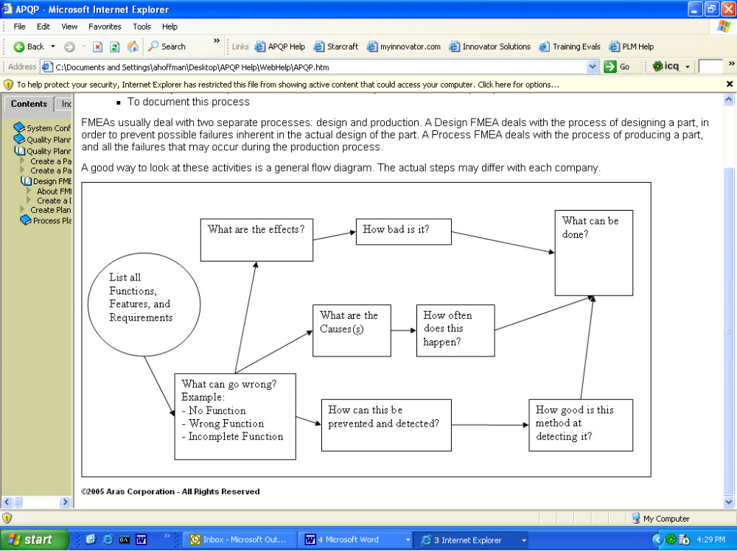

Create a DFMEA
The design responsible engineer works with a number of different documents. It is a good idea to begin the process with a list of what the Design is expected to accomplish.
- In the TOC tree click on the “+” to the left of Design to expand the folder.
- Select DFMEAs, right click and choose New or click the New icon on the toolbar.
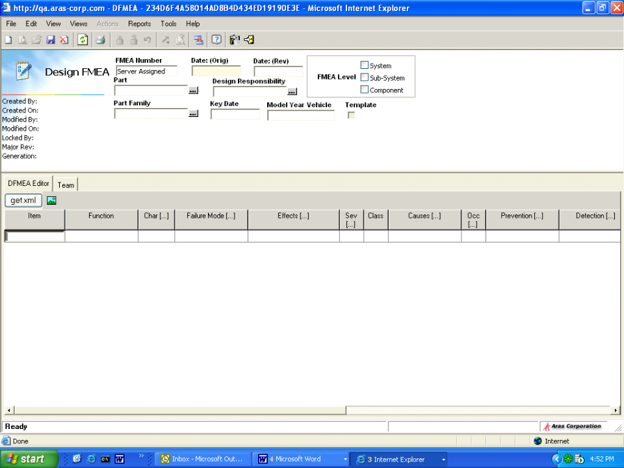

Header Properties
Label | Description
FMEA Number | Read only, system generated
Rev | Read only, keeps track of the revisions for this part. The default is A, or B etc.
Status | Read only, refers to the life cycle state of the part
Date: (Orig) | System generated date the FMEA was created
Date: (Rev) | System generated date of the latest revision
FMEA Level | System - usually made up of several sub-systems, each one designed by different teams. Typically, a system FMEA will focus on the interactions of the different sub-systems and the interface to its surroundings.  Sub-System - usually a subset of a larger system. Typically, a sub-system FMEA will focus on the interactions of various components in the sub-system and the interface to its surroundings.  Component - usually a small part of a system, like a strut in the front suspension subsystem.
Part | Actual Part associated with the DFMEA
Design Responsibility | The user or group responsible for the design of the FMEA Level
Part Family | Used to groups parts that have similar characteristics.
Key Date | Date in which PPAP is due
Model Year Vehicle | The year of the effected model if known
The FMEA Number, Date(Orig) and Date(Rev) are all system generated.
- Click the curser into FMEA Level and select Component.
- Click the ellipse for Part and click on the Run Search icon.
Note: You can only select a Part or a Part Family, both cannot be selected.
- Select 00-Houseing 123 from the search grid and click on the green checkmark icon.
- Click on the ellipse for Design Responsibility and click on the Run Search icon.
- Select Engineer One from the list and click on the green checkmarkicon.
- Click into Key Date and select a date from the calendar.
- Type Sedan / 1998 for the Model Year Vehicle.

DFMEA Editor Property tabs
Label | Description
Item | The particular item, part number or a description, responsible for the functionality
Function | The functionality of the item being analyzed; for each Item, a new function will start a new nested row.
Char | When this cell gains focus, the Characteristic browser is displayed. Select the characteristics that apply to the particular function being analyzed.
Failure Mode | The manner in which the item could fail; you can either type in an entry, or hit F2 to bring up a Failure Mode Catalog. You can start multiple nested rows at this point to indicate that for a specific function there are several failure modes that carry with them
Effects | The effects of a specific failure mode. The Effects Catalog is automatically displayed when the cell gains focus. Select one or more effects to be displayed as a comma separated list in the grid cell.
Sev | Severity is a rank associated with the most serious effect in the list. It is populated automatically, when the effects are selected.
Class | The class of the characteristic. If a characteristic is entered in this row's Char cell, its classification will automatically appear here. These options come from a configurable list where each company may enter their own classifications. Usually, the following would be available:  CC - Critical Characteristic  FF - Fit/Function  SC - Significant Characteristic  S - Safety/Compliance
Causes | Potential causes or mechanisms of failure. For each Failure Mode, there can be more than one cause. You can either type in a value, or hit F2 to select from a Causes Catalog. Each cause entered will start a nested row.
Occ | The likelihood of failure occurrence on a scale of 1 to 10. Once the cell gains focus, the Occurrence Catalog will display from which a selection can be made.
Prevention | Possible methods of preventing this failure from happening. A Controls Catalog displays to allow the user to select a prevention method.
Detection | Describes measurement techniques to be utilized to detect possible failures. A Measurement Technique Catalog can be used to select standard measurement methods appropriate to the situation
Det | The likelihood that the control method will catch the failure; select from the options presented in the popup dialog.
RPN | Risk priority number; automatically calculated based on previous entries. If the number is high enough (exceeds a company specified threshold), then actions need to be taken to lower it.
Actions | The actions that will take place to lower the RPN. The Reaction Plan Catalog contains a list of possible actions for the user to select. Once the appropriate data is filled out, the action is sent to the responsible personnel. That person then fills out the Task Completion Worksheet.
Role | The general department or group that will be responsible for the Actions. The options are Manufacturing, Design, or Evaluation.
Responsible | The specific personnel responsible for the Actions. When this field has a value of a particular identity, the actions will be sent to that person's InBasket to start the implementation process.
Target Date | A target date by which the specified actions should be completed.
Actual Date | The actual date when the actions are completed. This is filled out by the responsible personnel upon completion, in the Task Completion Worksheet.
Action Taken | The action taken by the responsible personnel. Echoed here from the Task Completion Worksheet.
Sev | The new severity, after the actions have been taken. The value is automatically copied from the Task Completion Worksheet.
Occ | The likelihood of failure occurrence on a scale of 1 to 10. Typically, after the actions are taken, the Occ should be decreased. The value is copied here automatically from the Task Completion Worksheet.
Det | The likelihood that the control method will catch the failure, again after the actions are taken. The value is from the Task Completion Worksheet.
RPN | The new value of the risk priority number, should be reduced below the company set threshold.

Creating the DFMEA Editor
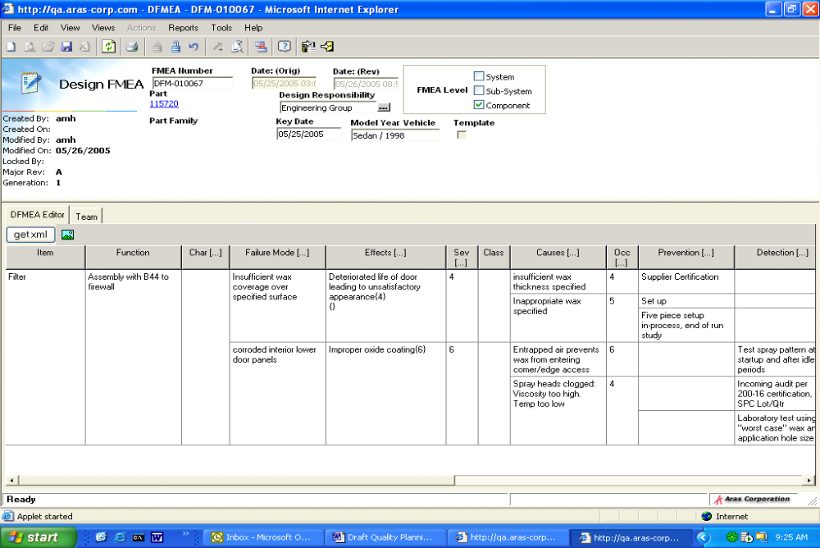
- Fill in the information into the applicable grid cell as shown in the diagram above.
Note: The Tab key can be used to move form cell to cell. When in a cell F2 will launch the dialog boxes needed to select the catalog information to be inserted.
Sometimes there is a need to create multiple entries that might apply to a particular Failure Mode, or a particular Effect. In other words, an entry might have more than one child dependent. For example, in the above diagram, there are 2 causes and 3 preventions that apply to the one Failure Mode and the one Effect. You can determine the parent and the children by the line going across the grid. That is called nesting a row.
- To create a nested row, with the curser in the cell where you wish to create the nested row, hit the insert key on the keyboard. The line will automatically be inserted from that cell across the dialog box.
For each line item entered into the grid, a user can be assigned the responsibility to complete the action. This action shows up in the user’s InBasket. To assign a user:
- Tab, or scroll across the grid until you see the label Responsible.
- Click in the cell and type F2 to launch the search dialog box, select Engineer One.
Note: The identity assigned in the Responsible cell should be an alias identity.
- The Actions cell is used to pass any instructions to the user.
- Click in the cell for Target Date and type F2.
- Select a target date from the calendar.
- Click Save, Unlock & Close icon on the toolbar.

View the InBasket
To view the InBasket:
- Login into Innovator as Eng1, Password 1.
- Click on the “+” to the left of My Innovator to expand the folder.
- Select My InBasket.
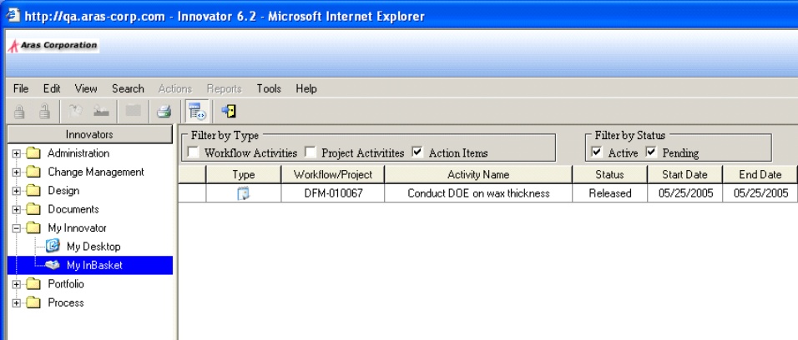
- Make sure Action Items is checked under Filter by Type section.
All Actions that have been assigned to you will appear in the grid.

Task Completion Worksheet
Once the action appears in the user’s InBasket, they can update the activity, add comments and then complete the action. To update the action:
- Right click on the action you wish to update and choose Update Action.
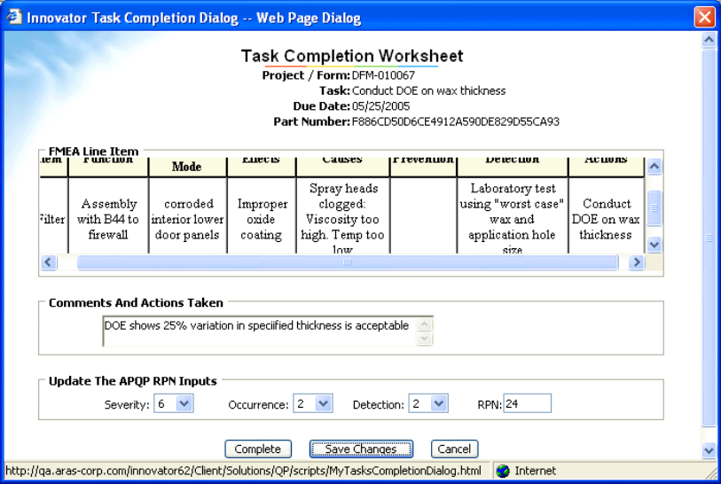
This will launch the Task Completion Worksheet.
- Type the following comment under for Comments And Actions Taken.
Based on test results (Test #9989) spray head modified.
- Fill in the Update The APQP RPN Inputs as follows:
  - Severity 6
  - Occurrence 2
  - Detection 5
  - RPN 60 (RPN will automatically fill in)
Note: This section must be filled in to complete a task
If the Task Completion Worksheet is not ready to be completed, the Save Changes button will save any changes made and the action will remain in the user’s InBasket. However, if the Task is complete:
- Click the Complete button at the bottom of the dialog box.
This completes the Task Completion Worksheet, removes the action from the user’s InBasket and updates the relevant information into the DFMEA.
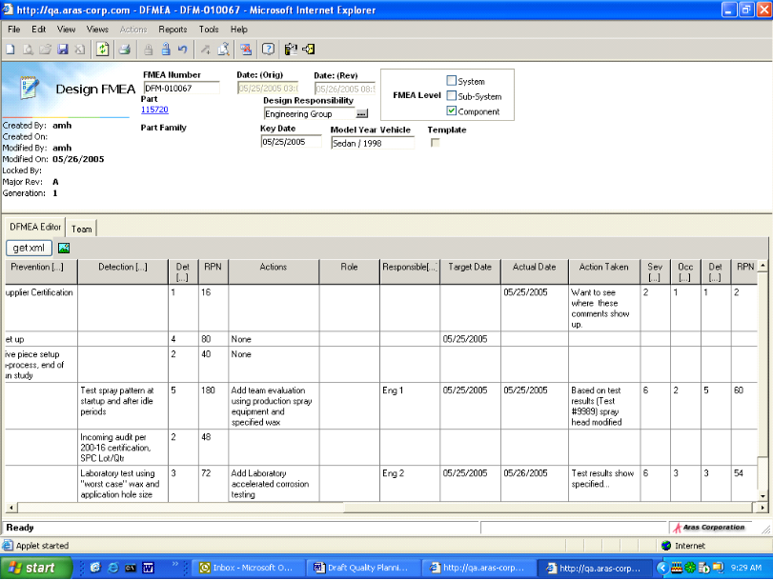

Plant Locations
Plant Locations are used in the Process Planner to identify the specific plant where the part is being manufactured. Plant location is important as different plants may produce the same part differently. This plays a large role when cloning plans, or creating templates

Create a Plant Location
- In the TOC tree click on the “+” to the left of Process
- Select Plant Location, right click and choose New or click on the New icon on the toolbar.
- Type Wyoming for the Location Name and 143-568-042 for the Location Duns (Dun & Bradstreet number).
- Repeat the above steps and create a second location.

Tools
In the Process Planner, Control Plan, for each operation, the user must provide a list of tools that will be used to perform a specific operation. There are two ways to create new tools. One way is directly from the TOC, similar to the catalog creation. The second way is from the Process Planner (Control Plan) tab.

Create a Tool
To create a tool from the TOC tree:
- In the TOC tree click on the “+” to the left of Process to expand the folder.
- Select Tools, right click and choose New or click on the New icon on the toolbar.
- Type TBD for the Tool name.
- Enter a description.
- Click on the Save, Unlock & Close icon on the toolbar.

Process Planner
The Process Planner is a combination of three separate documents that all share some properties. The three documents are:
    - Process Flow Diagram
    - Control Plan
    - Process FMEA
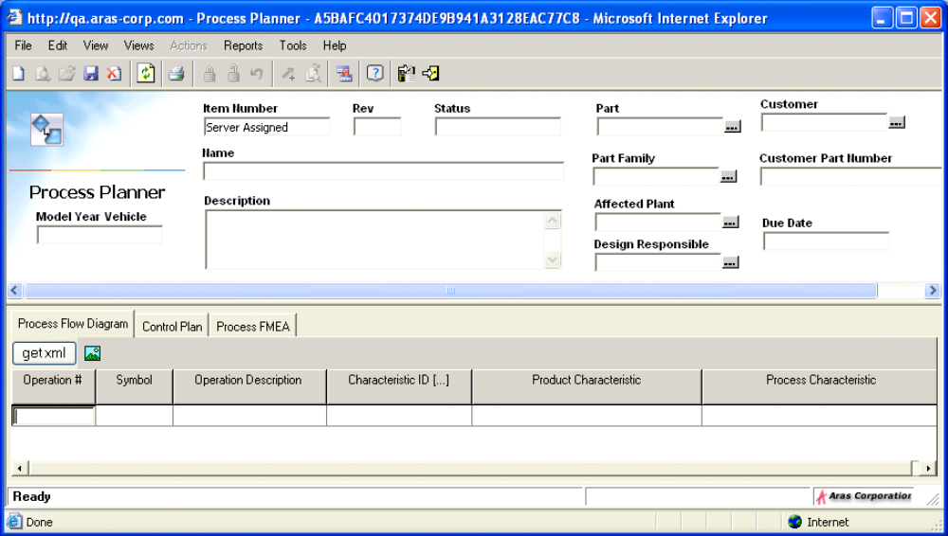
The shared properties include the ones that appear on the item header.

Header Properties
Label | Description
Item Number | Server assigned
Rev | System generated - Shows the revision status of the item
Status | System generated – Shows the life cycle state of the item
Model Year Vehicle | The intended model year(s) that will use the part being produced
Part | The part that this process produces
Part Family | The part family that this process produces. Used to group Parts with similar characteristics
Affected Plant | The plant location where the production takes place
Design Responsible | Person or group responsible for the design of the process used to produce this part or part family
Customer | The customer who is expecting the delivery of this part
Customer part number | The corresponding customer part number for the part being produced
Key Date | Date when the part production needs to be completed
All of the documents in Process Planner reference an operation number. An operation is a step in the process, which is numbered and described in many different ways by each of the documents. The operation number is the link between all three documents.

Process Flow Diagram

Create a Process Flow Diagram
- In the TOC tree click on the “+” to the left of Process to expand the folder.
- Select Process Planner, right click and choose New or click on the New icon on the toolbar.
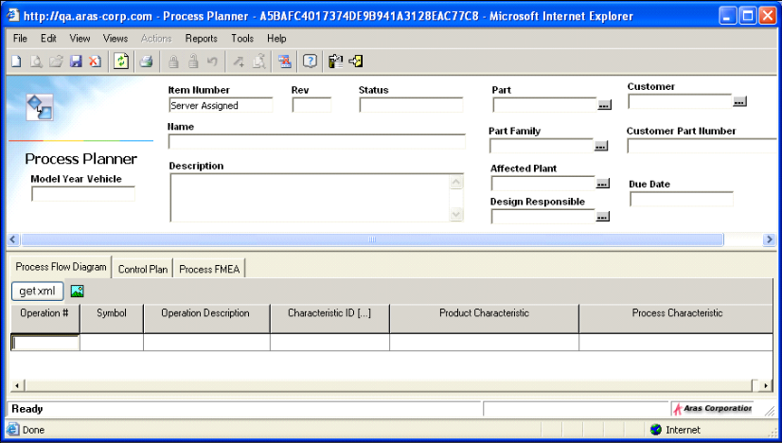
The Item Number is system generated along with the Rev and Status.
- Click into the Name and type Primary Drive Housing.
- Click on the ellipse for Part, in the search dialog box click on the Run Search icon on toolbar.
- Select 00- Housing 123 from the list, click on the green checkmark icon.
- Click on the ellipse for Affected Plant, in the search dialog box click on the Run Search icon on toolbar.
- Select Wyoming from the list, click on the green checkmark icon.
- Click on the ellipse for Design Responsible, in the search dialog box click on the Run Search icon on toolbar.
- Select Eng 1 from the list, click on the green checkmark icon.
- Enter a Due Date.
- Click into the Operation # cell in the relationship grid of the Process Planner dialog box.

Process Flow Diagram Property Tabs
Label | Description
Operation # | The shared operation number that links all three documents
Symbol | The symbol representing the type of operation, i.e., scrap, rework, move etc.
Operation Description | Description of the operation
Characteristic ID | The characteristic ID affected by the operation
Product Characteristic | System Generated. Enters the Characteristic description if the characteristic ID used is marked as D (Design)
Process Characteristic | System Generated. Enters the Characteristic description if the characteristic ID used is marked as P (Process)
- Type in OP 100 Step 1 for the operation number.
- Tab or click the mouse into the next cell. The Symbol dialog box will appear automatically. Select a symbol and click on the green checkmark icon on the toolbar.
- Tab or click into the Operation Description cell and type Pre-load dowel pins to fixture.
- Tab to Characteristic ID, the Characteristics dialog box will appear.
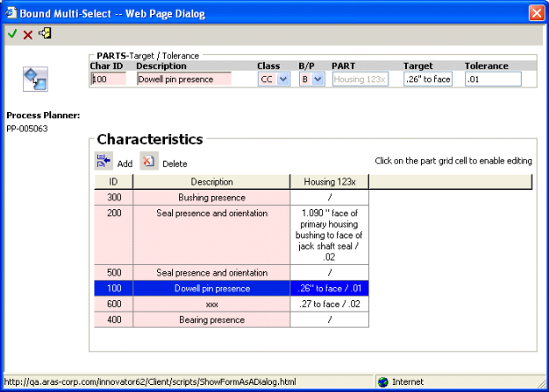
A list of characteristic will be displayed in this dialog, you can choose one of the characteristics listed or you can create a new characteristic by clicking on the Add button. Create a new characteristic:
- Click the Add button.
A new line in the grid will be entered.
- At the top of the dialog box click into Char ID and type 100.
- For Description type Dowell Pin Presence.
- From the drop down list for Class select CC.
- From the drop down list for B/P select B.
- The Part is already populated. For Target type .26 to face.
- For Tolerance type .01
- Click on the green checkmark icon on the toolbar.
The Characteristic ID and the Product Characteristic will be displayed in the grid.
Note: The Product Characteristic will populate if the characteristic is set to Design and the Process Characteristic will populate if it’s set to Process.
- Click on the Save, Unlock & Close icon on the toolbar.

Control Plan

Create a Control Plan
Edit the Primary Drive Housing Process Planner.
- In the TOC tree click on the “+” to the left of Process to expand the folder.
- Select Process Planner.
- Select Primary Drive Housing from the search grid, right click and choose Edit.
- Click on the Control Plan tab, it is the second tab in the Process Planner.
The left most portion of the grid is populated from the information entered into the Process Flow Diagram. The full details of the characteristics entered are displayed in the grid also. The field properties that were not included the Process Flow Diagram are as follows:
Label | Description
Machine Tools | The tools used in the company to perform the operation
Measurement Method | The method by which the result of the operation is measured.
Sample Size | Number of items or parts to be measured
Sample Freq | How often the measurement will take place.
Control Method | A brief description of how the operation will be controlled.
Reaction Plan | Specifies what corrective actions should take place to avoid producing bad products or operating out of control
- Click into the cell for Machine Tools.
A dialog box appears listing the machine tools if they have already been created via the Tools item in the TOC tree.
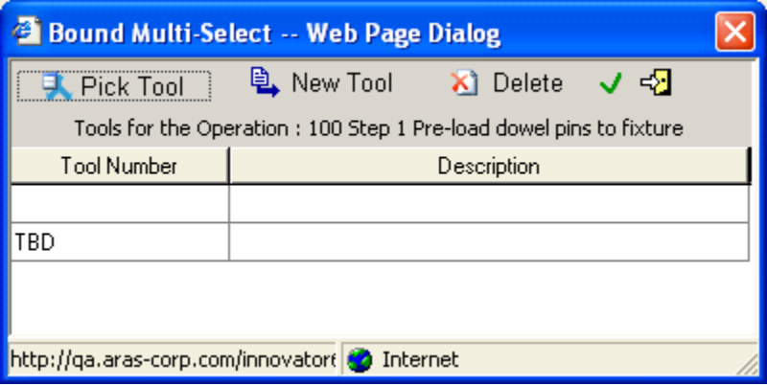
This list of tools is a Bound list. Bound lists are lists of data where the value entered into the field must be selected from the list itself, the user is not allowed to type in a value into the field. However, a new value can be added to the list by clicking on the New Tool icon, creating the tool and entering it into the field by clicking on the green checkmark icon.
To view an existing list of tools:
- Click on the Pick Tool icon.
- Click on the Run Search icon, a list of Tools will be displayed.
- Select the Tool and click on the green checkmark icon.
To add a new tool:
- Click on the New Tool icon.
- Type TBD for the tool name and leave the description blank.
- Click on the green checkmark icon.
- Tab to the Measurement Method cell and type Visual Inspection.
- Enter 100% for Sample Size and Sample Frequency.
- Type Per procedure Y13A. Control of Nonconforming Material for Control Method.
- For Reaction Plan, type –Rework in station. –Segregate NCF.
- Click on the Save, Unlock & Close icon.

Process FMEA

Create a Process FMEA
A Process FMEA is an analytical technique used by a Manufacturing/Assembly Responsible Engineer or group to identify whenever possible potential failure modes and their associated causes. Like the DFMEA it is a summary of the group’s thoughts and experience of what can go wrong during the process of producing a part.
- Click on the Process FMEA tab.
- The Operation # and the Description are automatically populated.
- Tab through the cell and fill in the data as listed in the table below.
Label | Entry
Function | Manual application of wax inside door
Failure Mode | Insufficient wax coverage over specified surface
Effects | Deteriorated life of door leading to: *Unsatisfactory appearance due to rust through paint over time  *Impaired function of interior door hardware
Severity | 7
Causes | Manual inserted spray head not inserted far enough
Occur | 8
Detection | Visual check each hour 1/shift for film thickness (depth meter) and coverage
Det | 5
Actions | Add positive depth stop to sprayer
Responsible | Eng 2
Target | Date
- Click on the Save, Unlock & Close icon.
When the Process FMEA is saved the action appears in the InBasket of the user assigned as responsible for the action. This user can update the action and complete it. As in the DFMEA once the action has been completed it will update the PFMEA with the appropriate information.
Once all the documents have been created and associated with the Part Template, they will appear in the template under the label Quality Planning Document.
Edit the 00-Housing 123 template to view the documents.
- In the TOC tree click on the “+” to the left of Design to expand the folder.
- Select Parts and click on the Run Search icon on the toolbar.
- Select 00-Housing 123, right click and choose Edit.
- Click on the tab Quality Planning Documents.
All four documents will be display. You are know ready to create new parts and clone the DFMEA and copy the Process Planning document into them, or, in our case create a Part Family with the new parts and copy the documents into the Part Family.

Deleting
Deleting information from the Process Planner whether in the PFD, CP or PFMEA, all act similar. The rules are listed in the table below.
Property | Rule
Operation # (shared over all forms) | Deletes the entire row / nested rows and all its children
Description (shared over all forms) | Deletes the data from the row but not the row itself
Machine tools (CP) | Deletes the data in this cell only
Char (shared over PFD & CP) | Deletes the reference to the Characteristic ID and everything to the right
Measurement method (CP) | Deletes the data in this cell and everything to the right, deleting all nested rows
Sample size/Sample frequency (CP) | Deletes the data in these cell and everything to the right, deleting all nested rows
Control Method/Reaction Plan (CP) | Deletes the data in these cells and everything to the right, deleting all nested rows

Parts

Create a new Part
The Parts dialog box contains all of the information needed to create a part and all of its related information, i.e., BOM, Documents, Target & Estimated Cost, and Quality Planning Documents etc. When the parts are created they will then become a Part Family. In this part family you can clone the DFMEA and copy the Process Planner documents from the template.
- In the TOC tree click the “+” to the left of Design to expand the folder.
- Select Parts, right click and choose New or click the New icon on the toolbar.
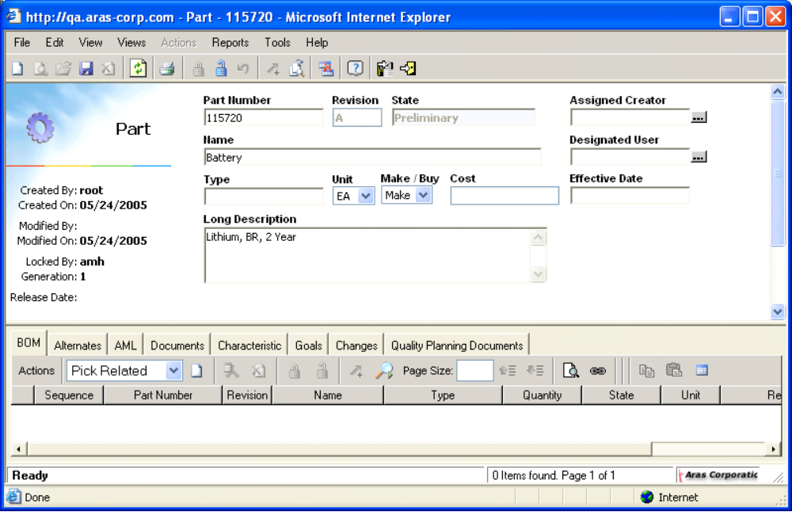
The Parts dialog box is split into two sections, the header and the related items. The header sections properties are listed below:
Property | Description
Part Number | The Part Number
Revision | Read only, keeps track of the revisions for this part. The default is A, or B etc.
State | Read only, refers to the life cycle state of the part
Name | The name of the part
Type | Select whether the part is a component, an assembly, a material or a software
Unit | Units of measure, inches, feet, millimeters, centimeters or meters
Make/buy | Is this part made in house or bought from a manufacturer
Unit | Measure of Unit, i.e., EA, IN, FT etc.
Reference Designator | Used to specify the exact part. For example, if the part was a car wheel, the reference designator would stipulate which wheel, front left etc.
- Type 650875 for Part Number and type Resistor for the Name.
- Revision and State are read only and will be populated when the part is saved.
Revision will display the latest revision, i.e., A, B etc., of the Part and the State will display the Part’s current Life Cycle state.
- Assigned Creator is the person responsible for creating the Part. This field can be assigned to an Identity. If no Identity is assigned then it defaults to the login user creating the Part.
- Designated User is the person responsible for using or editing the Part. If no Identity is assigned then it defaults to the login user creating the Part.
- Click into Type, the Classification dialog box appears. Click the “+” to the right of Parts.
The Classification Structure displays the various class types available for this Part.
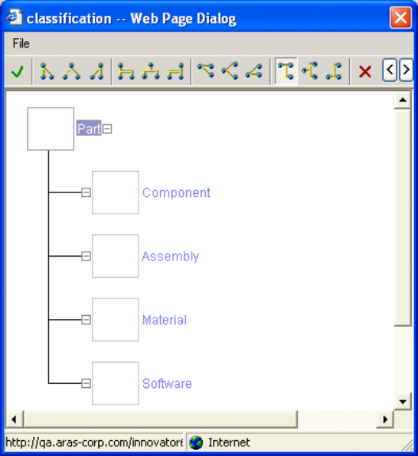
- Select Component and click the green checkmark icon on the toolbar.
- Fill in a Unit and Cost.
- Click on Effective Date and select a date from the Calendar.

Relationship Tabs
Field Name | Description
BOM | BOM Part
Alternates | An alternate part to replace existing part
AML | Approved Manufacturer List
Characteristics | Specify the Characteristics of a part
Goals | Set a Cost or Weight – Actual, Estimate or Target
Documents | Attach a document to a part
Changes | Changes made to a Part via, PR, ECR or ECN
Quality Planning Documents | DFMEAs, PFMEAs, PFD & CP
The two tabs relative to quality planning are Characteristics and Quality Planning Documents.

Characteristics
Characteristics are used to specify any special distinctions about the part, i.e., length, dimensions etc. There are a number of different places to create characteristics. One is in the relationship section of the Part dialog box. The other ways are though the DFMEA, PDMEA, PFD or CP.
Note: A characteristic would only be created using the relationship tab in the part dialog if the part is not to be included in a Part Family.

Create a Characteristic
- Click on the characteristic tab.
Property | Description
ID | Characteristic ID, or a number from the bubble drawing; usually a key characteristic identified by the Product Engineer or the Manufacturing Engineer (for process characteristics)
Description | Description of the Characteristic
Class | Class of Characteristic, i.e., FF, CC etc.
D or P Flag | Is this Characteristic a Design or a Process
Type | Dimensional refers to the characteristics, i.e., length, width etc. Material refers to the type of material chosen and Functional refers to the actual function this part is to perform, i.e., spin rate
Target/Specification | The target value for the characteristic. For example, the target measurement; material specification number; or some kind of process target such as the heat treatment needs to be at 300 degrees
Tolerance | Bounds for target. For example, if the characteristic is dimensional, tolerance could be +/-.01inches
- Fill in the following Characteristics as show in the table below:
ID | Description | Class | P or B Flag | Type | Target/Specification | Tollerance
100 | Resistance | FF | D |  | 120 ohm | ± 12
- Click on the Save, Unlock & Close icon on the toolbar.
- Repeat the above step to create the following Parts do not include any Characteristics:
Part Name | Type | Unit | Make/Buy | Long Description | Assigned Creator | Designated User | Effective Date
650875 | Component | EA | Buy | Resister | QP Admin | QP Admin | 4/4/05
161714 | Component | EA | Buy | Resister | QP Admin | QP Admin | 4/4/05
440897 | Component | EA | Buy | Capacitor | QP Admin | QP Admin | 4/4/05
240897 | Component | EA | Buy | Capacitor | QP Admin | QP Admin | 4/4/05
320897 | Component | EA | Buy | Capacitor | QP Admin | QP Admin | 4/4/05
522030 | Component | EA | Buy | Clip | QP Admin | QP Admin | 4/4/05
792554 | Component | EA | Buy | Circuit Board | QP Admin | QP Admin | 4/4/05
402117 | Component | EA | Buy | Resonator | QP Admin | QP Admin | 4/4/05
402919 | Component | EA | Make | Transistor | QP Admin | QP Admin | 4/12/05
115720 | Component | EA | Buy | Battery | QP Admin | QP Admin | 4/12/05

BOM
Once the above table of Parts has been created, assemble them as BOM parts into the main assembly part listed as follows:
- When creating the following parts, use Pick Related to create the BOM parts.
Part Name | Type | Unit |  | Make/Buy |  | Long Description |  | Assigned Creator |  | Designated User |  | Effective Date | Cost/Estimate
102595 | Assembly | EA |  | Make |  | Primary Parts Housing |  | QP Admin |  | QP Admin |  | 4/4/05 | 102595
BOM Parts
Sequence | Part Number |  | Revision |  | Name |  | Type |  | Quantity |  | State |  |  | Unit
 | 650875 |  |  |  | Resister |  | Component |  | 1 |  |  |  |  | EA
 | 430878 |  |  |  | Resister |  | Component |  | 2 |  |  |  |  | EA
- Continue creating the BOM, using all the part created in the previous table.

Create a Part Family
A Part Family groups parts that share common characteristics. There may be many cases where developing a FMEA for each part would involve much redundant work. Instead these parts can be grouped. Each of these groups or families can have their own DFMEA and Process Planner documents, while sharing a set of common characteristics. The target and tolerance for each characteristic is individual for each part. For example, say we are creating a FMEA for a family of screws. The characteristics that they share may be: length, diameter, thread, etc. However, for each particular part, the target length and tolerance would be different from the others. Remember also, any part that has a characteristic created in the part itself, cannot be used in a Part Family.
- In the TOC tree click the “+” to the left of Design to expand the folder.
- Select Part Family, right click and choose New or click the New icon on the toolbar.
- Name the Part PF001.
- Click on the New Relationship icon to the right of Pick Related.
- Click on the Run Search icon on the toolbar.
- Using the CTRL key, select the parts 102595 & 115720 and click on the green checkmark icon.
- Click on the Save, Unlock & Close icon on the toolbar.

Clone Documents
When the parts have been created and included in the Part Family, the Quality Planning Documents can be attached.
- In the TOC tree click the “+” to the left of Design to expand the folder.
- Select Part Family
- Click on the Run Search icon on the toolbar.
- Select PF001, right click and choose Edit from the menu.
- Click on the Quality Planning Documents tab.
- Click on Clone and click on the Run Search icon on the toolbar.
- Select 00-Housing 123 and click on the green checkmark icon.
- Click on Copy Process Planner and click on the Run Search icon on the toolbar.
- Select 00-Housing 123 and click on the green checkmark icon.
- Click on the Save, Unlock & Close icon on the toolbar.

Exercise 1

Add User
- In the TOC tree click the “+” to the left of Administration to expand the folder.
- Select Users, right click and choose New or click the New icon on the toolbar.
- Type Engineer for First Name and Two for Last Name.
- For the Login type Eng, Password 1.
- Enter a checkmark for Login Enabled.
- Click on the Save, Unlock & Close icon on the toolbar.
- Repeat the above steps to create Engineer Three.

Add an Identity to a Group
- In the TOC tree click the “+” to the left of Administration to expand the folder.
- Select Identities.
- In the search criteria line type in Q* or Q% and click on the Run Search icon on the toolbar.
- Select Quality Planning for the list, right click and choose Edit.
- Click the New Relationship icon to the right of Pick Related.
- Click on he Search icon on the toolbar.
- Select Engineer Two from the list and click the green checkmarkicon on the toolbar.
- Click the Save, Unlock and Close icon on the toolbar.
- Repeat the above steps and assign Engineer Three to the Engineering Group.

Exercise 2

Catalogs
- TOC tree click the “+” to the left of APQP Library to expand the folder.
- Select Failure Mode Catalog, right click and choose New or click the New icon on the toolbar.
- Type in the Insufficient wax coverage over specified surface.
- Type in the Usage Insufficient wax on filter with B44 to firewall.
- Click on the Save, Unlock & Close icon on the toolbar.
- Repeat the above steps to create the following catalogs:
Catalog | Name | Usage | Control Type
Failure Mode | Corroded interior lower door panels | Corroded Interior for Filter with B44 Firewall
Effects | Deteriorated life of door leading to: Unsatisfactory appearance due to rust through paint over time. Impaired function of interior door hardware | Unsatisfactory appearance due to rust for filter with B44 Firewall
Effects | Improper oxide coating
Cause | Insufficient Wax thickness specified
Cause | Entrapped air prevents wax from entering comer/edge access
Cause | Spray heads clogged: Viscosity too high, Temperature too low, Pressure too low
Controls | Supplier Certification |  | Prevention
Controls | Five piece setup, in-process, end of run study |  | Detection
Controls | Test Spray pattern at startup and after idle periods. |  | Prevention
Controls | Incoming audit per 200-16 certification, SPC Lot/Qtr |  | Detection
Controls | Laboratory test using “worst case” wax and application hole size |  | Detection

Exercise 3

View the InBasket
To view the InBasket:
- In the TOC tree click on the “+” to the left of My Innovator to expand the folder.
- Select My InBasket.
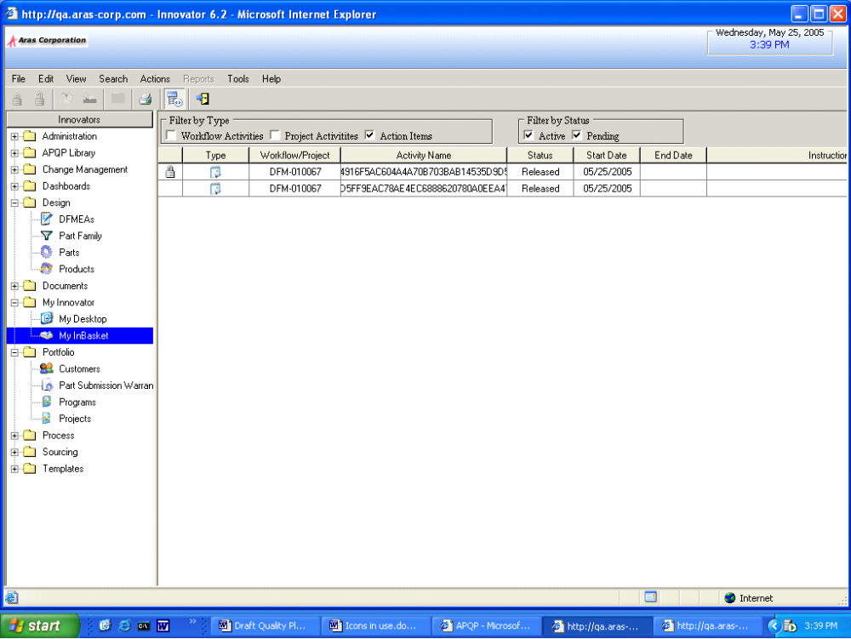
- Make sure Action Items is checked under Filter by Type section.
All Actions that have been assigned to you will appear in the grid.

Update the Action
- Update each of the actions listed in the InBasket.
- Right click on the action you wish to update and choose Update Action.
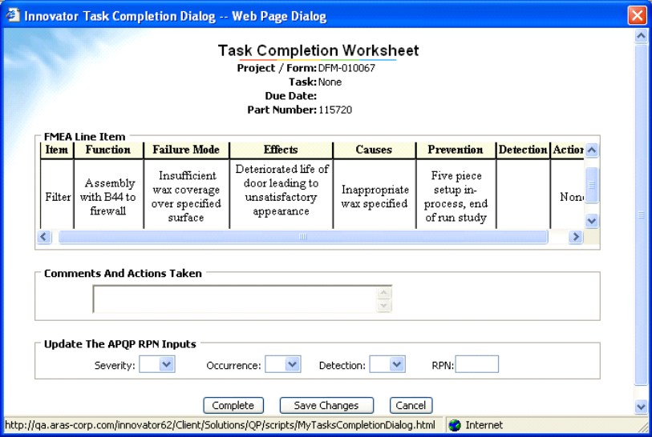
- Add the following comment to the Comments and Actions Taken.
a. Test results show specified corrosion
  - Severity 6
  - Occurrence 3
  - Detection 3
  - RPN 54 (RPN will automatically fill in based on Detection)
b. DOE shows 25% variation in specified thickness is acceptable
  - Severity 6
  - Occurrence 2
  - Detection 2
  - RPN 24 (RPN will automatically fill in based on Detection)

Exercise 4

Process Flow Diagram
Edit the Primary Drive Housing Process Planner and add the following operations to the Process Flow Diagram.
- In the TOC tree click on the “+” to the left of Process to expand the folder.
- Select Process Planner.
- Select Drive Housing Process Planner from the search grid, right click and choose Edit.
- Type in OP 100 Step 2 for the operation number.
- Tab or click the mouse into the next cell. The Symbol dialog box will appear automatically. Select a symbol and click on the green checkmark icon on the toolbar.
- Tab or click into the Operation Description cell and type Pre-load jack shaft seal to fixture.
- Tab to Characteristic ID, the Characteristics dialog box will appear.
- Click the Add button.
A new line in the grid will be entered.
- At the top of the dialog box click into Char ID and type 200.
- For Description type Seal presence and orientation.
- From the drop down list for Class select SC.
- From the drop down list for B/P select B.
- The Part is already populated. For Target type 1.090” face.
- For Tolerance type .02
- Click on the green checkmark icon on the toolbar.
The Characteristic ID and the Product Characteristic will be displayed in the grid.
- Repeat the above steps to create the rest of the operations listed in the diagram below. Creating the following Characteristics.
Char ID | Description | Class | B/P | Target | Tolerance
300 | Bushing presence |  | P
400 | Bearing presence |  | P
500 | Seal presence and orientation | MC | P

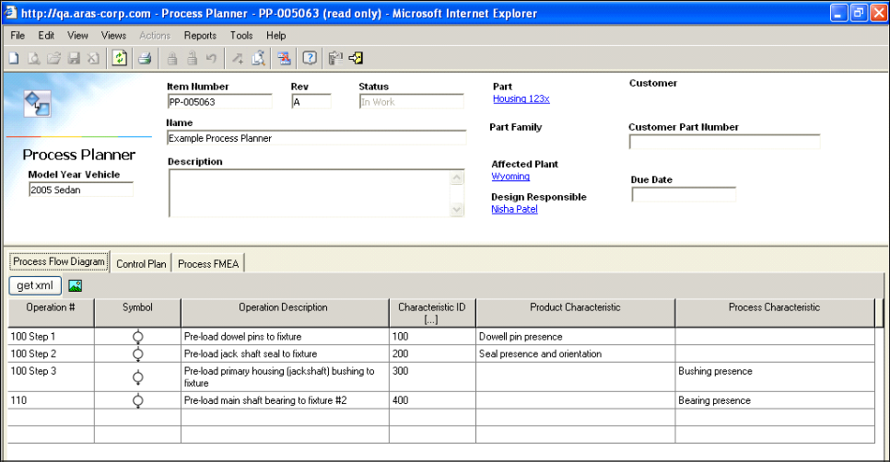
- Click on the Save, Unlock & Close icon on the toolbar.

Exercise 5

Control Plan
Edit the Primary Drive Housing Process Planner and add the same information to all the operating steps in the Control Plan.
- Expand the Process folder by clicking the “+”.
- Select Process Planner.
- Select Drive Housing Process Planner, right click and choose Edit.
- Click on the Control Plan tab, it is the second tab in the Process Planner.
- Click into the cell for Machine Tools.
A dialog box appears listing the machine tools if they have already been created via the Tools item in the TOC tree.
This list of tools is a Bound list. Bound lists are lists of data where the value entered into the field must be selected from the list itself, the user is not allowed to type in a value into the field. However, a new value can be added to the list by clicking on the New Tool icon, creating the tool and entering it into the field by clicking on the green checkmark icon.
- Click on the Pick Tool icon.
- Click on the Run Search icon, a list of Tools will be displayed.
- Select the Tool and click on the green checkmark icon.
- Tab to the Measurement Method cell and type Visual Inspection.
- Enter 100% for Sample Size and Sample Frequency.
- Type Per procedure Y13A. Control of Nonconforming Material for Control Method.
- For Reaction Plan, type –Rework in station. –Segregate NCF.
- Click on the Save, Unlock & Close icon.

